Unit 6: Weather
Chapters 15, 16 & 17 in Textbook
Definitions to know:
Meteorology is the study of the atmosphere- including weather.
Weather is the condition of the atmosphere. It can change from time to time and place to place.
Climate is the type of weather an area has over a long period of time.
The layers of the atmosphere are separated by different temperature variations.
The atmospheric layers:
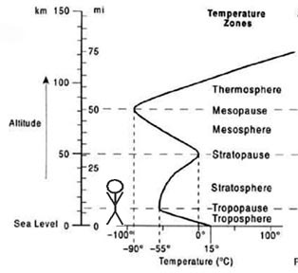
Troposphere

- We live in the troposphere.
- 0-18 km
- Gets colder as you go up.
- All weather occurs here
- "The Troublesphere”
- All water vapor in the atmosphere is here

Stratosphere
- Temperatures get warmer as you go up.
- Home of the Ozone layer.
Mesosphere & Thermosphere
- Upper layers of the atmosphere.
- The air is very thin here.

There are many atmospheric variables. These can all be measured, and change from moment to moment:

- Temperature
- Air Pressure
- Wind Speed and Direction
- Water content and humidity
- Cloud Cover
- Precipitation
- Others (dust, pollen, etc).

Temperature – the average kinetic energy of molecules. Heat enters the atmosphere through solar radiation.
What does that look like?

There are 3 ways to measure temperatures:
Fahrenheit
- Water freezes at 32°
- Water boils at 212 °
Celsius
- AKA Centigrade (100 levels)
- Water freezes at 0 °
- Water boils at 100 °
- Makes more sense and is easier to make a thermometer
Kelvin
- Same scale as Celsius but 0 means zero energy
- No degrees mark for Kelvin, just K.
- 0K means that all atomic vibrations stop – what would this mean?
Converting Temperature

To convert °C into °F: °F = (°C x1.8) + 32
To convert °F into °C: °C = (°F - 32) ÷ 1.8
To convert °C into Kelvin K = °C + 273.15
To convert K into °C: °C = K -273.15

Food for thought:

- Energy always go from high to low.
- There is no such thing as “cold”.
Cold is just an absence of heat.
- Ice doesn’t add cold to something.
It sucks the heat into it.
- Heat flows from hot to cold

There are 3 ways to transfer heat:
Radiation

Conduction

Convection

